INSTRUCTIONS

*Note: Bahina ni ninyo ang duha, ang full details sa DATA DESIGN (Data Dictionary, Entity Relationship Diagram) naa sa ubos with screenshots*

* Data Dictionary
* Entity Relationship Diagram

*Note: Akoy buhat sa System Flowchart, then pili mo og laing usa para buhaton, para duha ang output under ani nga part*

* Data and Process Modeling (Either of the following two (2), whichever is applicable:)
* Context Diagram
* Data Flow Diagram
* System Flowchart
* Program Flowchart (highlights only)
* Class Diagram
* Sequence Diagram
* Activity Diagram

*Note: Ako ni paninguhaon mahuman nako ang Gantt Chart*

* Gantt Chart

*Note: Kamo buhat sa Fishbone Diagram*

* Fishbone Diagram

**DATA DESIGN BASIS**

Sa Data Design, I base ang Data Design og Entity Relationship Diagram  
  
Database name: reservation  
Database tables:  
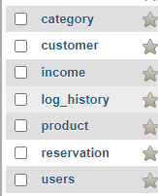  
  
Category table:  
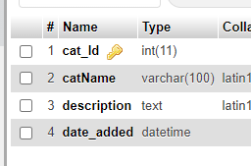

Customer table:

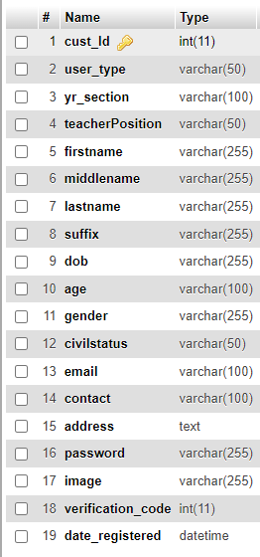

Income table:

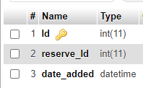

Log_history table:

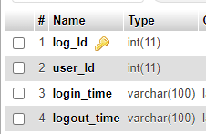

Product table:

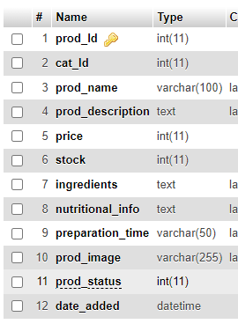

Reservation table:

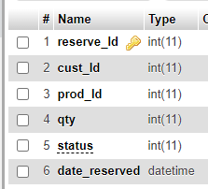

Users table:

